Digital Marketing in the Age of Claude Code, Gemini, and Vibe-Coding: How Many People Does Your Marketing Team Need?
When I led Go-to-Market (GTM) activities at an Atlassian Solution Partner, our operations were structured around distinct functional capabilities:
- A product marketer to decode complex features into value propositions.
- A content writer to draft case studies and thought leadership.
- A performance specialist to adjust ad spend, keywords, and bids.
- A CRM lead to wire together nurture triggers and scoring logic.
- A social media manager to chop long-form assets into daily posts.
- A designer to package everything visually.
Each of these capabilities was tied to one or two specialists. In addition, we had team members who brought essential language skills and cultural context for the regional markets we targeted.
We were equipped with the modern standard: best-in-class tools for CMS management, lead tracking, automated workflows, and campaign attribution. Everything a high-performing digital marketing team could ask for.
Our culture was grounded in collaboration, mutual support, and transparent communication. We protected the time we needed to stay in sync, ran structured sprint planning cycles, and consistently hit both company-wide mandates and our own departmental KPIs.
Up until around 2024, this was the gold standard for how a digital marketing engine should run.
Then agentic AI arrived. Tools like Claude Code, specialized autonomous agents, and vibe-coding environments arrived.
The specialized, siloed marketing team was turning into an artifact. The manual execution layer was collapsing into code.
From the outside—unencumbered by corporate planning cycles and headcount politics—the reality is obvious: Most companies do not need an eight-person digital marketing team. They need about one person backed by a fleet of AI agents.

What Does a Modern Digital Marketing Function Actually Require?
If autonomous agents handle drafting, asset resizing, scheduling, variant generation, bid management, and analytics reporting, what is left for the human?
Digital marketing ceases to be an assembly line of manual tasks and becomes an exercise in architecture, governance, and positioning. Stripped to its essentials, the discipline now divides cleanly into three pillars:
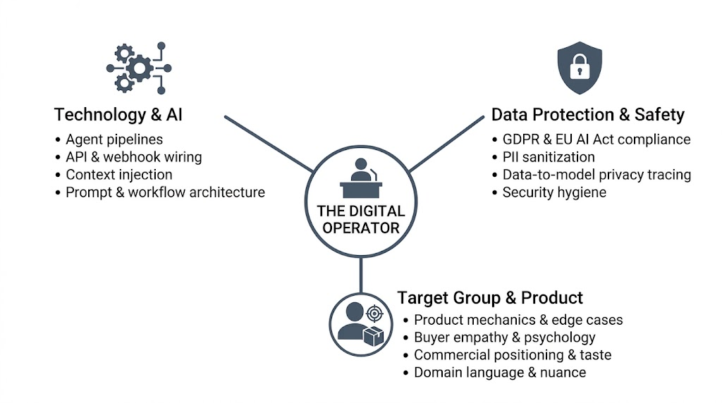

1. Technology & AI Mastery (The Orchestration Layer)
The marketer must be genuinely technical. This goes far beyond typing prompts into a web chat. It means understanding API integrations, context window limitations, prompt chaining, local LLMs, and autonomous agent loops. They need to know how to connect an ad platform’s API to an internal analytics warehouse, automate lead-routing logic, and debug unexpected hallucinations or dropped webhooks.

2. Data Safety & Privacy Regulation (The Governance Layer)
Autonomous agents run on proprietary data. The moment you deploy agentic systems across CRM records, sales transcripts, tracking pixels, and internal documentation, you enter a strict regulatory landscape:
- Regulatory Compliance (GDPR, EU AI Act, CCPA): Knowing what data can legally be processed by third-party model providers versus what must be self-hosted, encrypted, or anonymized.
- PII Sanitization: Ensuring personal customer data, email bodies, and billing records are scrubbed before reaching external training sets or commercial APIs.
- Data Security Hygiene: Preventing credential leakage, prompt injection vulnerabilities, and unauthorized data exfiltration within automated inbound funnels.
A marketer lacking privacy and governance literacy will build an automated pipeline that exposes the organization to severe legal and reputational liability.

3. Product & Target Group Empathy (The Strategic Layer)
This is the un-automatable core. The operator must understand the product's edge cases, technical realities, commercial friction points, and the visceral emotional drivers of the target buyer. They need editorial taste. Without this, even the most sophisticated AI stack will simply blast high-velocity, generic noise into the market.

The Convergence Law: One Brain Beats Three Desks
Could an organization simply hire three people—one technologist, one privacy/compliance officer, and one product strategist?
Certainly. But every handoff reintroduces the exact bottleneck agentic AI is designed to eliminate: translation loss and operational latency.
Model | Campaign Velocity | Translation Loss | Operational Overhead
Traditional Team (6–8 specialists) | Weeks per campaign | High (telephone game across silos) | Extreme (endless syncs and alignment meetings)
Triad Split (3 specialists) | Days per campaign | Moderate (waiting on compliance & engineering) | Moderate (cross-functional dependencies)
Single High-Leverage Operator | Hours per campaign | Zero (strategy, tech & governance in one head) | Minimal (direct execution via agent fleets)
Every handoff creates drag. If the person who understands the buyer has to draft a spec for a developer to configure the agent, who then has to wait for a compliance review on data flow, the agility vanishes.
The more these three competencies converge in a single person, the faster and cleaner the execution becomes.

Why the Shift Hasn’t Fully Hit (Yet)—and Why I Stepped Out
If the economics and operational advantages are this obvious, why are companies still staffing multi-layered digital marketing teams to write briefs and run retrospective syncs?
The barrier isn't the technology. The tech is already here. The barrier is organizational, institutional, and human inertia:
- The Executive Knowledge Gap: Many leadership teams still equate AI with asking ChatGPT to summarize a meeting transcript. Because they haven't seen vibe-coding or terminal-based agents in production, they cannot fathom an entire marketing stack run by a single operator.
- Empire-Building & Headcount Vanity: In many corporate environments, status is measured by team size. Managing a 15-person department feeds executive ego far more than running headless automation scripts from a single laptop.
- Corporate IT Red Tape: Enterprise shadow IT concerns frequently freeze adoption. Waiting six months for an API token or a security review pushes teams back toward sluggish, legacy SaaS suites simply because they are already vendor-approved.
- Labor Realities & Human Loyalty: Strong labor protections, contractual notice periods, and genuine workplace empathy naturally slow radical restructuring. Good leaders develop real loyalty to their teams and are hesitant to eliminate roles that people rely on.
That final point is precisely why I am writing this from the outside.
As Head of GTM, I hired those people. I shaped our culture. I took pride in our sprint velocity, our shared wins, and how we supported one another through every launch. It was a healthy, high-functioning team.
When I recognized how quickly agentic AI was maturing, the conclusion was inescapable: the organizational structure had an expiration date. But I had no desire to play corporate survival games, sharpen my elbows, and position myself as the "last man standing" presiding over the gradual unwinding of a team I had built.
I didn't want to manage that decline. So I stepped out to build and consult independently on my own terms.
The companies that win the next phase of digital marketing won't be the ones waiting for traditional corporate machinery to catch up. They will be the lean operations that bypass the handoffs, eliminate the headcount overhead, and empower a single, context-rich conductor to out-execute entire legacy departments before lunch.

